AEC Approved Document_009_Template_Mouse Score System_V3.0

Mouse Score System Guidance (please delete this section when submitting your score sheet for approval):

The use of the Mouse Score System is to ensure that there are clear directions for managing animals that may be showing indicators of pain and distress, whether as a result of experimental manipulation or during general holding.

The Mouse Score System is used to assess an individual mouse and provide a holistic or overall score that reflects the overall health, condition and welfare of the mouse. The use of an holistic or overall score system creates a consistent approach to assessing animal welfare across the University and allows for clearer and more efficient communication between researchers, animal technicians and veterinary staff, and ultimately better welfare outcomes.

This Mouse Score System Is used in conjunction with the Mouse Grimace Scale that can be found here: https://www.nc3rs.org.uk/3rs-resources/grimace-scales/grimace-scale-mouse

The use of a Mouse Score System, as well as the frequency of monitoring and planned intervention points, must be approved in an animal ethics protocol. Any changes to an approved Mouse Score System must be approved by the AEC. If an urgent change is required, ANU veterinary services must be contacted immediately.

The following template is a guide and should be adjusted to include parameters that are specific to your experiments and strain(s) of mice. You must add the protocol details on the Mouse Score System once approved.

If you have any queries or would like advice on tailoring this Mouse Score System to your requirements, please contact ANU veterinary services at vetservices.ris@anu.edu.au

Using this score system: mice should be allocated to a score if they display one or more of the descriptors listed for that score. If you are unsure, the mouse should be allocated to the higher score, and/or vet services can be contacted for further advice.

Mouse Score System
Score | Description | Action | Picture Examples
0 | - The mouse: moves easily around the cage,  - has a smooth coat, and no external wounds or other injuries,  - has a body condition score of 3-4/5  - interacts with cage mates, including resting in a nest with co housed mice,  - scores '0' on the mouse grimace scale | No action needed. | 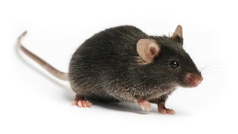
1 | The mouse:  - moves easily around the cage and postures up to explore cage,  - is slightly hunched at rest or when moving,  - has a body condition score of 5/5  - scores '1' for any facial expressions listed on the mouse grimace scale,  - is affected by a non-systemic condition, ie. mild skin irritation/dry skin without any bleeding, small areas of hair loss, scabbing on the tail (without any bleeding), etc. | Initial actions:  - Provide food, wet food and/or hydrogel on the cage floor.  - Clip nails if skin irritation is present.  Monitoring:  - The mouse must be placed on a weekly monitoring card.  - Weekly scoring can cease when a mouse has maintained 3 consecutives scores of '0'.  - ANU veterinary services should be contacted if the mouse scores '1' for 3 consecutive weeks and researchers require the animal to be maintained. | 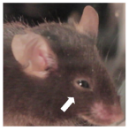  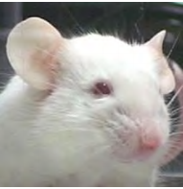
2 | The mouse:  - has a poor/ruffled coat,  - has reduced movement in the cage, doesn't posture up to explore cage  - is obviously hunched,  - has a body condition score of 2/5  - scores '2' for any facial expressions listed on the mouse grimace scale,  - has irritated surgical sites,  - has lacerations or injuries that are bleeding,  - has respiratory changes eg. rapid or shallow breathing. | Initial actions:  - Provide food, wet food and/or hydrogel on cage floor.  - Clip nails if skin Irritation or lacerations are present.  Monitoring:  - The mouse should be placed on a daily monitoring card.  - The mouse should be weighed every 48 hours.  - ANU veterinary services should be contacted if scoring '2' for 3 days and researchers require the animal to be maintained.  Protocol specific interventions at this score may include*:  - Pain relief  - Topical treatments for wounds | 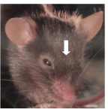  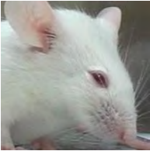

3 | The mouse  - has very reduced movement and/or only moves around cage when disturbed,  - is very hunched at rest and while moving  - scores '2' for any facial expressions listed on the mouse grimace scale,  - has surgical sites or wounds, ulceration, or lacerations with discharge, areas of necrosis or significant irritation, and/or an open wound  - has wounds or abnormalities of the genitalia that are affecting urination/ability to birth (e.g. preputial swelling or vaginal prolapse)  - has a rectal prolapse  - has difficulty breathing  - has lost 10% or more body weight over a 48-hour period | Mouse should be humanely killed unless this progression is expected and approved on your animal ethics protocol^.  OR  Initial actions:  - Provide food, wet food and/or hydrogel on cage floor.  Monitoring:  - ANU veterinary services should be contacted if condition is unexpected, and researchers require animal to be maintained.  - After discussion with veterinary services, monitoring may include twice daily scoring and weighing every 48 hours.  Protocol specific interventions at this score may include*:  - Pain relief (or additional pain relief)  - Administration of SC or IP fluids  - Topical treatments for wounds | 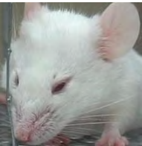  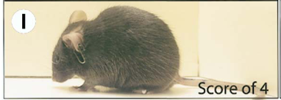
4 | The mouse:  - is moribund -ie. does not move when disturbed,  - has lost 20% or more body weight from baseline or initial recorded weight  - has a body condition score of 1/5  - has wounds covering 25% of the body surface area, and is unable to be treated  - has injuries that are unable to be treated, ie. fractured limbs, broken down or necrotic surgery sites | Mouse must be humanely killed.  No protocol should have approval for animals to be kept at score 4.
^ Seek veterinary advice if research program has a justification for keeping the mouse, and to discuss possible interventions to support the welfare of the animal.
* Approved interventions (e.g. pain relief, or the administration of saline SC or IP) must be easily accessible to research staff if and when it is required (e.g. in the room where animals are kept).

Research Impact Assessment
Are adverse events expected from this protocol? Y / N
If so, please outline expected adverse events for this protocol below, and include any relevant clinical signs in the score system above.
Expected adverse events:

Are animals that develop expected or unexpected adverse events still able to provide you with quality research data? Y / N
- If no: animals should be humanly killed at earliest possible time point (eg. score "2")
- If yes: researchers must have a clearly defined end point where animals will be humanly killed. Specific indicators related to the protocol must be clearly identified in the mouse score system

Can the following supportive therapy be provided without impacting your research data?
If specific treatments for your project are identified, these should be added to the “Action” section in the mouse score system template.

Intervention | Possible impacts on research | Able to use?
Food on floor of cage, wet food and water gel (e.g. hydrogel) | No impact | Y / N
Recovery gels – with glucose etc | No impact, unless a specific diet is required for the experiment | Y / N
Trimming nails | No impact | Y / N
Eye ointment (e.g. Conoptal) | Minimal systemic effects, unlikely to impact research | Y / N
Fluid support (e.g. sterile saline/ Hartmann’s) | Minimal systemic effects, unlikely to impact research | Y / N
Trisolfen (indicated for tail tipping/sample collection) | Minimal systemic effects, contains lignocaine, bupivacaine, adrenaline and cetrimide; researchers should assess possible impact | Y / N
Local anaesthetic (e.g. EMLA topically or lignocaine by injection) | Minimal systemic effects; researchers should assess possible impact | Y / N
Non-steroidal anti-inflammatory drugs (e.g. meloxicam) | Reduces inflammation and therefore may not be suitable for some projects | Y / N
Steroid containing drugs (e.g. Neocort) | Reduces inflammation and therefore may not be suitable for some projects | Y / N
Opioids (e.g. buprenorphine) | Analgesic, immunomodulatory and therefore may not be suitable for some projects | Y / N
Other (project specific intervention) |  | Y / N

