AEC Approved Document_009a_Template_Aged Mouse Score System V4.0

Aged Mouse Score System Guidance (please delete this section when submitting your score sheet for approval):

The use of the Aged Mouse Score System is required for any mice older than 12 months of age.

The use of the Aged Mouse Score System is to ensure that there are clear directions for assessing the welfare of older mice, which display a different set of observable lesions and clinical changes than younger mice. The Aged Mouse Score System is used to assess an individual mouse and provide a holistic or overall score that reflects the overall health, condition and welfare of the mouse. The use of a holistic or overall score system creates a consistent approach to assessing animal welfare across the University and allows for clearer and more efficient communication between researchers, animal technicians and veterinary staff, and ultimately better welfare outcomes for the animals.

This Aged Mouse Score System is used in conjunction with the Mouse Grimace Scale that can be found here: https://www.nc3rs.org.uk/3rs-resources/grimace-scales/grimace-scale-mouse

The use of the Aged Mouse Score System, as well as the frequency of monitoring and planned intervention points, must be approved in an animal ethics protocol. Any changes to an approved mouse score system must be approved by the AEC. If an urgent change is required, the ANU Vets must be contacted immediately.

The following template is a guide and should be adjusted to include parameters that would be specific to your experiments and strain(s) of mice. You must also add the protocol details on the Aged Mouse Score System once approved.

If you have any queries or would like advice on tailoring this Mouse Score System to your requirements, please contact ANU veterinary services at vetservices.ris@anu.edu.au
Using this score system: mice should be allocated to a score if they display one or more of the descriptors listed for that score. If you are unsure, the mouse should be allocated to the higher score, and/or vet services can be contacted for further advice.

Aged Mouse Score System
Score | Description | Action | Picture Examples
0 | The mouse:  - has a body condition score of 3-4/5,  - has a smooth or slightly ruffled coat including small areas of alopecia (less than 10% of coat),  - moves easily around the cage, and normal nesting behaviour,  - scores '0' on the mouse grimace scale. | Monitoring:  - The mouse must be placed on a weekly monitoring card.  - Baseline weight to be taken at 12 months of age for comparison if deterioration occurs. | 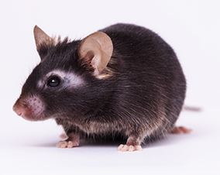
1 | The mouse:  - has a body condition score of 5/5  - has reduced mobility, e.g. is slower, or has mild changes to gait when moving around the cage,  - will still posture up to explore cage,  - scores '1' for any facial expressions listed on the mouse grimace scale,  - is affected by a non-systemic condition, ie. mild skin irritation/dry skin or more generalised alopecia (more than 10% of coat affected),  - has cloudy eyes (increased opacity of the corneas) without discharge or redness. | Initial actions:  - Provide food, wet food and/or hydrogel on the cage floor.  - Clip nails if skin irritation is present.  Monitoring:  - Continue weekly scoring.  - Record weight weekly.  - ANU veterinary services should be contacted if the mouse scores '1' for 3 consecutive weeks and researchers require the animal to be maintained. | 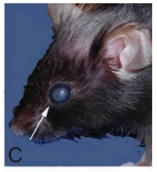  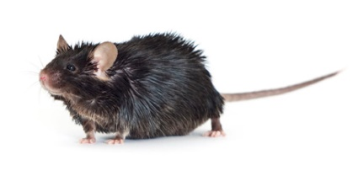
2 | The mouse:  - has a body condition score of 2/5  - Is mildly hunched when moving or at rest,  - has reduced mobility and only looks around the cage with prompting,  - scores '2' for any facial expressions listed on the mouse grimace scale,  - has a coat in poor condition, including larger areas of alopecia (25% of coat affected),  - has dermatitis/Irritated skin lesions,  - has discharge and redness around one or both eyes,  - has lost 10% or more body weight, over a 48 -hour period,  - has lacerations or injuries that are bleeding. | Initial actions:  - Provide food, wet food and/or hydrogel on the cage floor.  - Clip nails if skin irritation is present.  Monitoring:  - Increase monitoring to daily.  - The mouse should be weighed every 48 hours.  - Contact ANU veterinary services if scoring '2' for 2 days and researchers require the animal to be maintained.  Researchers are asked to consider humanely killing aged mice scoring '2'.  If mice are required to be kept at score "2" for a short period of time, ANU veterinary services may suggest the use of:  - pain relief  - topical treatments for wounds  - administration of SC or IP fluids | 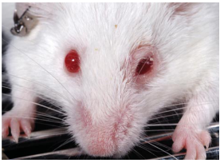  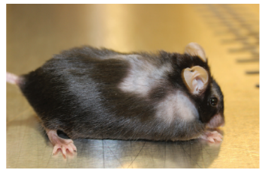
3 | The mouse:  - has poor movement around cage,  - is very hunched when moving or at rest,  - scores '2' for multiple facial expressions listed on the mouse grimace scale,  - has moderate to severe dermatitis, with skin lesions bleeding,  - has a rectal prolapse,  - has swelling of one or more joints,  - has tumours or swelling that can be seen or felt,  - has lost 20% or more body weight from baseline or initial recorded weight  - has a body condition score of 1/5  - has difficulty breathing. | Mouse should be humanely killed unless this progression is expected and approved on your animal ethics protocol^. | 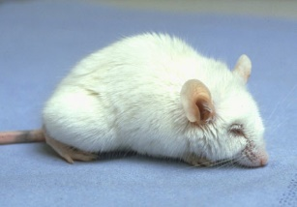

Research Impact assessment
Are adverse events expected from this protocol? Y / N
If so, please outline expected adverse events for this protocol below, and include any relevant clinical signs in the score system above.
Expected adverse events:

Are animals that develop expected or unexpected adverse events still able to provide you with quality research data? Y / N
- If no: animals should be ethically culled at earliest possible time point (e.g. score "2")
- If yes: researchers must have a clearly defined end point where animals will be ethically culled. Specific indicators related to the protocol must be clearly identified in the mouse score system

Can the following supportive therapy be provided without impacting your research data?
If specific treatments for your project are identified, these should be added to the “Action” section in the mouse score system template.

Intervention | Possible impacts on research | Able to use?
Food on floor of cage, wet food and water gel (e.g. hydrogel) | No impact | Y / N
Recovery gels – with glucose etc | No impact, unless a specific diet is required for the experiment | Y / N
Trimming nails | No impact | Y / N
Eye ointment (e.g. Conoptal) | Minimal systemic effects, unlikely to impact research | Y / N
Fluid support (e.g. sterile saline/ Hartmann’s) | Minimal systemic effects, unlikely to impact research | Y / N
Trisolfen (indicated for tail tipping/sample collection) | Minimal systemic effects, contains lignocaine, bupivacaine, adrenaline and cetrimide; researchers should assess possible impact | Y / N
Local anaesthetic (e.g. EMLA topically or lignocaine by injection) | Minimal systemic effects; researchers should assess possible impact | Y / N
Non-steroidal anti-inflammatory drugs (e.g. meloxicam) | Reduces inflammation and therefore may not be suitable for some projects | Y / N
Steroid containing drugs (e.g. Neocort) | Reduces inflammation and therefore may not be suitable for some projects | Y / N
Opioids (e.g. buprenorphine) | Analgesic, immunomodulatory and therefore may not be suitable for some projects | Y / N
Other (project specific intervention) |  | Y / N

