Document 030 Oral Gavage Mouse Score System V2.0

Mouse Score System Guidance (please delete this section when submitting your score sheet for approval):

The use of the Mouse Score System is to ensure that there are clear directions for managing animals that may be showing indicators of pain and distress, whether as a result of experimental manipulation or during general holding.

The Mouse Score System is used to assess an individual mouse and provide a holistic or overall score that reflects the overall health, condition and welfare of the mouse. The use of an holistic or overall score system creates a consistent approach to assessing animal welfare across the University and allows for clearer and more efficient communication between researchers, animal technicians and veterinary staff, and ultimately better welfare outcomes.

This Mouse Score System Is used in conjunction with the Mouse Grimace Scale that can be found here: https://www.nc3rs.org.uk/3rs-resources/grimace-scales/grimace-scale-mouse

The use of a Mouse Score System, as well as the frequency of monitoring and planned intervention points, must be approved in an animal ethics protocol. Any changes to an approved Mouse Score System must be approved by the AEC. If an urgent change is required, ANU veterinary services must be contacted immediately.

The following template is a guide and should be adjusted to include parameters that are specific to your experiments and strain(s) of mice. You must add the protocol details on the Mouse Score System once approved.

If you have any queries or would like advice on tailoring this Mouse Score System to your requirements, please contact ANU veterinary services at vetservices.ris@anu.edu.au
Using this score system: mice should be allocated to a score if they display one or more of the descriptors listed for that score. If you are unsure, the mouse should be allocated to the higher score, and/or vet services can be contacted for further advice.
All mice must be monitored for 7 days post oral gavage.
Substance given by oral gavage:
Expected side effects expected from treatment (if any):

Mouse Score System - Oral Gavage
Score | Description | Action | Picture Examples
0 | The mouse:  - has a smooth coat,  - has a body condition score of 3-4/5  - moves easily around the cage,  - interacts with cage mates, including resting in a nest with co housed mice,  - scores "0" on the mouse grimace scale. | Monitoring:  - All mice must be scored once daily for 7 days post oral gavage. | 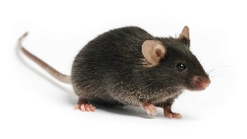  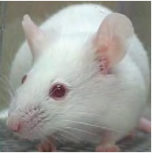
1 | The mouse:  - has a body condition score of 5/5  - moves easily around the cage and postures up to explore cage,  - is slightly hunched at rest or when moving,  - scores "1" for any facial expressions listed on the mouse grimace scale. | Initial actions:  - Provide food, wet food and/or hydrogel on the cage floor.  Monitoring:  - Continue daily monitoring.  - Weigh mouse twice weekly. | 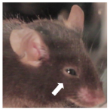  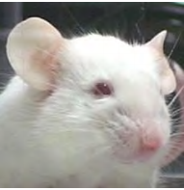
2 | The mouse:  - has a poor/ruffled coat,  - has a body condition score of 2/5  - has reduced movement in the cage, and doesn't posture up to explore cage,  - is obviously hunched,  - scores "2" for any facial expressions listed on the mouse grimace scale,  - has lost 10% or more body weight, over a 48 -hour period,  - has any respiratory changes eg. increased rate or rapid or shallow breathing. | Initial actions:  - Provide food, wet food and/or hydrogel on cage floor.  Monitoring:  - Increase monitoring to twice daily.  - Weigh mouse daily.  - ANU veterinary services should be contacted if scoring "2" for 2 consecutive days. | 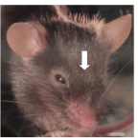  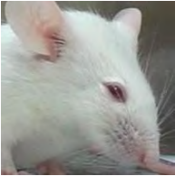

3 | The mouse  - has very reduced movement and/or only moves around cage when disturbed,  - is very hunched at rest and while moving,  - scores "3" for any facial expressions listed on the mouse grimace scale,  - has difficulty breathing, Including Increased respiratory rate, audible respiratory sounds, laboured or abdominal breathing,  - has nasal discharge,  - has lost 20% or more body weight from baseline or initial recorded weight  - has a body condition score of 1/5 | Mouse should be humanely killed.  OR  Contact ANU veterinary services for advice If research program has significant benefit for keeping the mouse. | 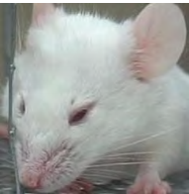  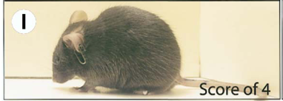

Oral Gavage Monitoring and Record Keeping Requirements
- All mice must be monitored daily for seven (7) days post oral gavage.
- The person who undertook the gavage or a trained representative from the research group must undertake the checks, in addition to routine checks by animal care staff.
- Records of the procedure and monitoring must be available with the cage card. This information must be clear and decipherable with the following information:
  - The route of administration
  - The substance given (including dose in mg/kg or equivalent)
  - Volume given
  - The date and time of administration
  - The initials of the person performing the procedure
  - Contact details (phone number and email) of researcher
- All procedures must have two (2) forms of records - cage level (cage card) and relevant database

Research Impact Assessment
Are adverse events expected from this protocol? Y / N
If so, please outline expected adverse events for this protocol below, and include any relevant clinical signs in the score system above.
Expected adverse events:

Are animals that develop expected or unexpected adverse events still able to provide you with quality research data? Y / N
- If no: animals should be humanely killed at earliest possible time point (eg. score "2")
- If yes: researchers must have a clearly defined end point where animals will be humanely killed. Specific indicators related to the protocol must be clearly identified in the mouse score system

Can the following supportive therapy be provided without impacting your research data?
If specific treatments for your project are identified, these should be added to the “Action” section in the mouse score system template.

Intervention | Possible impacts on research | Able to use?
Food on floor of cage, wet food and water gel (e.g. hydrogel) | No impact | Y / N
Recovery gels – with glucose etc | No impact, unless a specific diet is required for the experiment | Y / N
Trimming nails | No impact | Y / N
Eye ointment (e.g. Conoptal) | Minimal systemic effects, unlikely to impact research | Y / N
Fluid support (e.g. sterile saline/ Hartmann’s) | Minimal systemic effects, unlikely to impact research | Y / N
Trisolfen (indicated for tail tipping/sample collection) | Minimal systemic effects, contains lignocaine, bupivacaine, adrenaline and cetrimide; researchers should assess possible impact | Y / N
Local anaesthetic (e.g. EMLA topically or lignocaine by injection) | Minimal systemic effects; researchers should assess possible impact | Y / N
Non-steroidal anti-inflammatory drugs (e.g. meloxicam) | Reduces inflammation and therefore may not be suitable for some projects | Y / N
Steroid containing drugs (e.g. Neocort) | Reduces inflammation and therefore may not be suitable for some projects | Y / N
Opioids (e.g. buprenorphine) | Analgesic, immunomodulatory and therefore may not be suitable for some projects | Y / N
Other (project specific intervention) |  | Y / N

