# Document 032: Wildlife Marking Guidelines

## Background

The purpose of this document is to provide guidance on acceptable techniques marking wildlife for individual identification. Methods should be appropriate for the target species, and carried out in a way that will minimise pain and distress to the animal.

As per the NHMRC's Code Section 3.3.33 and 3.3.34:

3.3.33 The wellbeing of wildlife must be supported and safeguarded by:

1. using methods, techniques and equipment that:
   1. are appropriate for the species and the situation, and the purpose and aims of the project or activity
   2. minimise the risk of transmission of disease, and direct and indirect disturbance to the habitat
2. avoiding or minimising harm, including pain and distress:
   1. to target and non-target species
   2. to dependent young
   3. from indirect effects arising from impact on the habitat and environment.

3.3.34 To minimise the risk of injury or stress-induced disease, procedures for the capture and handling of wildlife must include:

1. the involvement of a sufficient number of competent people to restrain animals in a quiet environment and prevent injury to animals and handlers
2. chemical restraint (e.g. sedatives) where appropriate, if the period of handling is likely to cause harm, including pain and distress, to animals
3. restraint and handling of animals for the minimum time needed to achieve the purpose and aims of the project or activity
4. making provisions for captured animals that are ill or injured, including treatment of pain and distress.

The method used must be in accordance with current best practice.

#### Definitions

**Capture myopathy:** Condition associated with the capture and handling of some species of mammals and birds that results in degeneration of skeletal and/or cardiac muscle

**Marking** - the process by which an animal is given an individual or cohort identifier. Marks may be temporary, permanent or semi-permanent

**Target Species** - animal intended to be marked

**Refinement** - selection of processes or techniques to reduce impact on animals.

## General Information and Considerations

### Temporary methods

#### Paints and dyes

## Paint and dye can be easily applied directly to the hair, fur or skin of many animals and is a highly visible form of marking. Application most often involves painting the mark directly onto the animal by hand using stencils and brushes, paint pens, liquid paper or nail polish, or more remotely with brush-tipped poles. Only non-toxic paints and dyes should be used. The longevity of this type of marking is a few weeks to several months and depends on hair shedding (moulting), wear (rubbing) and fade (e.g. dyes). Consider whether the paint or dye will alter the animal’s behaviour (increased grooming) or increase their visibility to predators or prey. There are many scenarios in which paint and dyes are not recommended:

## Amphibians due to their potential to be toxic to the skin or interfere with the skin's role in water and gas exchange.

## Birds’ wings due to their potential to interfere with aerodynamics

* Animals with very thick fur, as grooming may cause ingestion, and fur matting may cause fur loss and skin irritation.

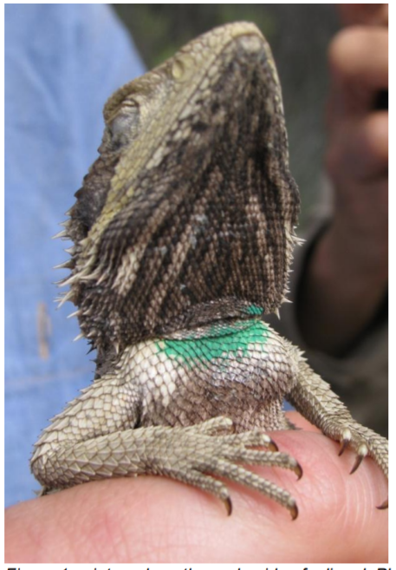

Figure 1: Paint on lizard Source: J. Frawlec

#### Fur removal

## Fur can be clipped from parts of the body that are easily visible to the observer while not interfering with its visibility to predators or prey. This method is suitable for short term studies, with mark longevity dependant on rate of fur growth (usually a few weeks to months). The use of powered clippers should be avoided if possible, as the noise can be an additional stressor. For larger animals, unique marks (e.g. numbers/combinations) may be applied to facilitate individual identification. Avoid removing too much fur, to reduce the possibility of sunburn or hypothermia.

### Semi-permanent methods

## Semi-permanent markers are those that are required to last for months to years. Most marks are lost during the lifetime of the animal or are removed after recapture.

#### Ear tags

## The tag must be of an appropriate size, shape and colour to permit normal behaviour and prevent snagging on vegetation or overgrooming. The person attaching the ear tag must understand the ear anatomy of the animal to avoid blood vessels and select optimal attachment points. The application site must be disinfected with ethanol prior to application, and Tri-Solfen® applied after application (this may be species-dependent; check with the ANU vet team for advice).

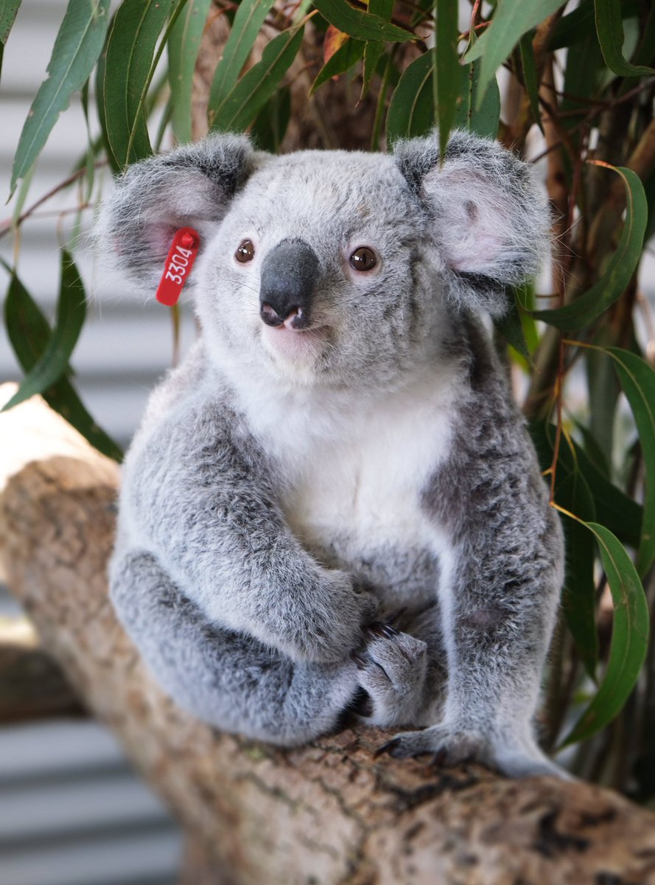

Figure 2: Ear tag koala Source: Australia Zoo

#### Scale-clipping and branding

## This is effective in species with numerous, large scales, particularly ventral scales (i.e. snakes). Clipping a scale or combination of scales can be reliable for short-term mark-recapture studies; however, clips do deplete over time, particularly during sloughing as the animal grows. The method and equipment must be appropriate for the size of the animal and care must be taken to prevent injury to deeper tissue. Tri-Solfen® should be applied to the affected area after clipping to prevent infection.

### Permanent methods

## Permanent marks are those that are unlikely to be lost during the life of the animal.

#### Tattooing

## Animals of all sizes can be tattooed, with the advantages being that they add no weight, do not alter behaviour and do not make the animal more conspicuous to predators. However, tattooing requires prolonged restraint during application, the process is potentially painful, and the animal may require restraint again when the tattoo is read. The most commonly tattooed area is the inside surface of the pinna of the ear. The area tattooed should be lightly pigmented, clean and relatively hairless (such as the pinna) and should not be a contacting surface for the animal. The tattoo should be large enough that it can still be legible as it ages. If possible, tattooing should be done while the animal is anaesthetised or a topical anaesthetic application used (options can be discussed with the ANU veterinarians).

#### Freeze branding

## Freeze branding involves making a permanent, individual mark to part of the body by applying a branding iron that has been supercooled in liquid nitrogen or a dry ice and alcohol mixture or a commercial refrigerant. Freeze branding has been successfully applied in mammals, birds, reptiles, anurans and cetaceans. The primary disadvantage is that a period of weeks is required after application before the brand becomes evident and the process is also known to be painful. Again, where possible, freeze branding should be done under anaesthesia or a topical anaesthetic applied as advised by the ANU veterinarians.

## The operator must be skilled in the application of this technique, as the brand may become less distinct with time. Applying the brand for too long can cause injury and a bald scar, not applying the brand for long enough can fail to produce an identifiable mark. Brands should be applied in a position which is easy to see for resight purposes but does not place the animal at greater predation risk. The optimal length of time and temperature of brand application varies between species and must be tested on the species before use in the field, unless the technique has previously been successfully used in that species.

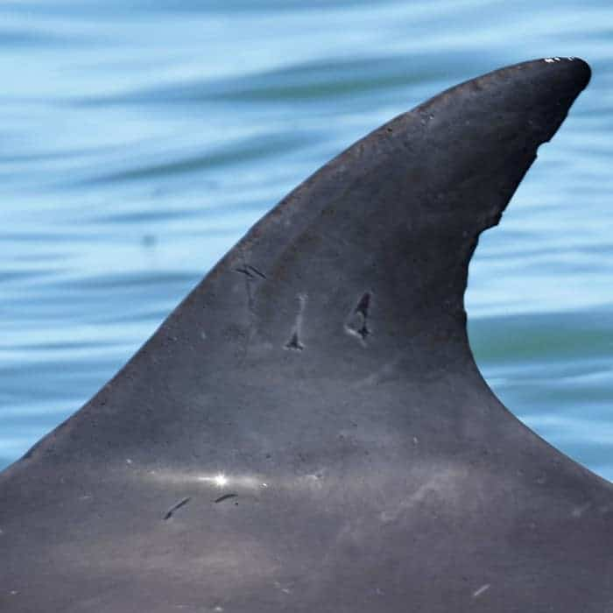

Figure 3: Freeze branding in a dolphin Source: Mandurah Cruises

#### Passive integrated transponders (PIT tags)

## Passive Integrated Transponders (PIT) are small, durable microchips that have no power supply. A hand-held scanner passed over the PIT (‘scanning’) generates a low energy radio signal that energises the PIT tag to transmit a unique number. PITs are quick to apply, long lasting, reliable and provide unequivocal identification. Their small size and weight do not normally alter the behaviour or appearance of the animals. Implantation of PIT tags is usually only briefly painful but it may result in prolonged pain and/or infection if placed too deep or if there is poor disinfection and handling. Animals often need to be recaptured to identify individuals, although they require only short-term restraint. In some cases, scanning may occur passively as the animal moves past or through a scanner, minimising the need for handling. Appropriate restraint, anaesthetic, asepsis and analgesia must be used. All PIT tag marking must be conducted using sterile injectors and tags. PIT weight can be used in both small and large animals but should not generally exceed 5% of the body weight. The operator must have training and knowledge of appropriate sites of implantation for their target species (eg dorsal sac/ IP in Xenopus frogs, subcutaneously in small mammals, intracoelomically in reptiles and intramuscularly in birds), and must be consistent in their location. For some animals such as small rodents, anaesthesia may be required to prevent movement and ensure that the PIT tag is implanted in the appropriate area, as movement can cause penetration into the spine or body cavity. In some cases PIT tags do not need to be implanted, such as when they are attached to leg bands of birds.

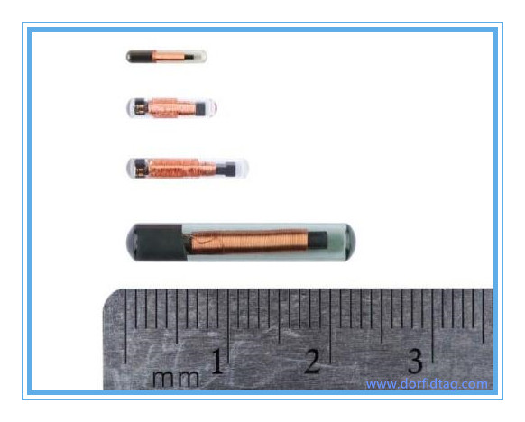

Figure 4: Example of different sizes of PITs Source: Idaho Fish and Game

#### Banding

##### *Numbered ABBBS metal bands*

## Metal bands are supplied by the Australian Bird and Bat Banding Scheme (ABBBS), and have a unique number to allow individual recognition. The size must be appropriate for the bird species, following guidelines from the ABBBS. In general, bands should be just tight enough not to slip over the foot, or the intertarsal joint. A band that is too tight may not allow leg skin to slough properly or may compromise blood supply, which can cause infection and even death. A band that is too loose has the potential to cause entrapment of the foot or beak, or snag on objects from the environment such as sticks or branches.

The bander must have completed the required training and certification from ABBBS. Generally banding can be done without anaesthesia.

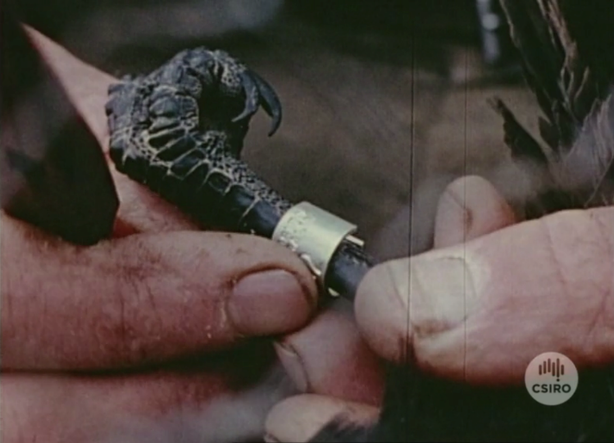

Figure 5: Bird Banding Source: CSIRO

##### *Colour bands*

## Colour bands can allow identification of cohorts or individuals based on the colour or combination of colours. Some larger colour bands can also be etched with numbers or letters to allow another method of individual recognition. The banding scheme must be approved by the ABBBS in advance, again using the approved sizes. Bands can be made of different materials – such as darvic, cellulose or metal – and may be glued or heat-sealed. Seek advice from the ABBBS on what materials are appropriate for the specific species, as inappropriate materials can lead to serious injury. Application of bands must be by suitably trained people, normally only those certified by the ABBBS.

*Wing tags*

Wing tags are a semi-permanent way of marking birds with numbered plastic tags attached with a stud through the patagium on one or both wings. Wing tags allow easy identification of individuals at distance, either by researchers or by members of the public. They have been effectively used in citizen science programmes around the world. Ensure that the tag is of an appropriate size, shape and colour to permit normal behaviour and to prevent any loss of flight ability or flight efficiency. The application site must be disinfected with ethanol prior to application to prevent infection, and alcohol gel can additionally be used to smooth feathers, allowing a clear visual assessment of the patagium. The person attaching the wing tag must understand the anatomy of the study animal to avoid blood vessels.

#### Visible implant elastomer (VIE)

## A visual elastomer compound is injected into the ventral surface of the animal, just under the skin, with a syringe. Elastomer markings can be highly visible to the naked eye in some species such as geckos and fish. In other species, an LED or UV light will enhance visual identification. Several elastomer marks can be injected into many parts of the ventral surface, allowing for a wide range of combinations and patterns.

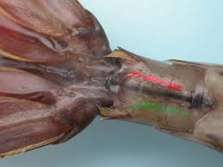

Figure 6: VIE in a crustacean Source: Aquacultur.de

#### Toe-clipping

## Toe clipping should be avoided unless there is no alternative, and only considered for species which are unlikely to be adversely affected. Toe clipping can be acceptable for species where locomotor performance is likely to be unaffected and for which there are no better alternatives. Species where toe-clipping is likely unsuitable include arboreal geckos, arboreal frogs (some treefrogs) and other species where toes play a critical role in locomotion and climbing on smooth, vertical surfaces. Consult with other researchers and the veterinarians to explore suitable marking methods for your study species. Please also read the supplement on toe-clipping (*see. Appendix 2*). In instances where toe clipping is approved, pain relief in the form of topical analgesia such as Tri-Solfen® will need to be applied at a dose appropriate for the species. The veterinarians can advise on the appropriate dilution of this product depending on the size of the animal.

#### Scute notching

## A simple, non-destructive technique that allows thousands of permanent/semi-permanent combinations. Suitable mainly for freshwater turtles, whereby a single (or multiple) scute is notched with a file or grinder and is suitable for short or long-term mark-recapture studies. Care must be taken to prevent injury to soft tissue during handling.

## Refinement

Selection of the method of marking should be as such to minimise the impact on the animal and to prevent any physical or physiological impairment.

## Permit requirements

Requirements for permits vary from state to state and the researcher must be aware of the conditions of the permit and abide by all requirements under the relevant legislation. It is the responsibility of the primary investigator to organise these permits before marking animals. Please note that banding of birds requires authority from the Australian Bird and Bat Banding Scheme (ABBBS), which requires extensive training.

## Hygiene

## Equipment that comes into direct contact with animals should be disinfected or sterilised before being used on a new animal. Organic material such as tissue, dirt and body fluids should be removed before disinfection. Ethanol is a suitable disinfectant.

Some species have specific hygiene protocols to prevent the spread of infectious diseases (eg chytrid fungus in amphibians). The researcher should be aware of these requirements and include them in their ethics protocol.

## Health and Safety

As per ANU guidelines, researchers must complete a risk assessment before marking animals. Handling of animals presents risk to the researcher both through physical trauma, such as from as bites and scratches, as well as the transfer of zoonotic diseases, such as salmonella from reptiles and lyssavirus from bats. The researcher should assess the risks, and explain in the ethics proposal the precautions needed to minimise risk.

## Euthanasia

If euthanasia is required, it must be carried out by a skilled operator, using the technique appropriate for the species and approved in their protocol, or taken to a veterinary clinic that has been arranged by the researcher before the start of research (see 016 Field Euthanasia Guidelines).

## Monitoring, Intervention and Reporting

Marking procedures must be recorded systematically. Include data on the person performing the procedures, samples and measurements taken, the individual animal’s identification, age and sex, and any observations relevant to animal welfare and the research itself. The protocol must explain methods, and identify any potential impacts to the animal's welfare.

Researchers must comply with all reporting requirements under the relevant permit and legislation of the state in which they are conducting the research. The researcher must submit annual reports to the Australian National University's Animal Ethics and Experimentation Committee (AEEC). In addition to routine reporting, any occurrences that are not foreseen, and impact research and animal welfare, must be included in an unexpected adverse report (UAE) with 72 hours of the event. This will then be assessed by the AEEC at their next meeting (see Procedure for Managing & Reporting Unexpected Adverse Events).

## Minimum Requirements

* The method of marking must be appropriate to the target species
* Marking should not interfere with the animal's ability to find food, avoid predators or seek shelter. It must not cause any sort of physical or physiological compromise.
* Toe clipping should be avoided if possible, and is only acceptable for some species
* The method of restraint during marking should be appropriate for the species. Chemical immobilisation should be considered for animals that are dangerous, or where the marking method causes pain and distress or predisposes them to capture myopathy.
* Animals must be released at a time that is biologically appropriate and will not impact their ability to find food or escape predation (see Document 023 Wildlife Trapping Guidelines).
* PIT weight must not exceed 5% of the body weight of animals in most circumstances
* Hygiene measures should be appropriate for marking method and also prevent harm to the species.

## Appendices

Appendix 1: Recommended techniques for taxa

|  |  |  |
| --- | --- | --- |
| Taxa | Examples | Acceptable Marking Technique |
| Small mammals | New Holland Mouse, Quolls, Bettongs | Fur clipping, PIT, tattooing, paints and dyes, ear tags |
| Large Mammals | Kangaroos, Cetaceans | Fur clipping, freeze branding, PIT, tattooing, paints and dyes, ear tags |
| Birds | Parrots, magpies, finches | Metal and colour banding, PIT, wing tags |
| Amphibian | Frogs, salamanders | PIT, VIE |
| Reptiles | Turtles, skinks, bearded dragons | PIT, VIE, scute notching (turtles), paints and dyes, toe-clipping if essential and safe |
| Fish | Marine, temperate and tropical fish | VIE, PIT |

Appendix 2: Toe Clipping Supplement

**From RSB and Fenner School Researchers to AEEC for consideration, Nov 2021.  
Toe-clipping as a method for marking small vertebrates**

The ability to track individual animals through their lives is a crucial element of lab and field-based research in ecology and evolutionary biology. Without unique identification most questions cannot be answered.

Toe-clipping has been used extensively for permanent, individual identification in small vertebrates, particularly lizards and frogs (see Ferner, 2007; Perry et al. 2011). It is a well-developed method that is very effective, easily applied, has minimal impact on animal welfare, and does not compromise performance and fitness for many small vertebrates (Langkilde and Shine, 2006; Borges-Landáez and Shine 2003; Perry et al. 2011). In many species, given their small size, it is the only means to individually identify animals.

In addition to a means of marking individuals, toe-clipping is also a valuable method for collecting material for histological examination (e.g. skeletochronology) and genetic analysis in herpetological studies. For frogs in particular, obtaining genetic samples any other way is exceedingly difficult or impossible. In these cases, generally a single toe is removed, which has not been associated with negative effects (McCarthy and Parris 2004).

Evidence that toe-clipping has negative effects is often species-specific. While effects can occur for some tree-dwelling species such as treefrogs and arboreal geckos, most species show no discernible impact. Even within species results are inconsistent, and often vary with time. For example, Langkilde and Shine (2006) evaluated a range of standard procedures commonly applied in wildlife research in a skink (*Eulamprus heatwolei*) to evaluate stress responses including: capture and handling, toe-clipping, blood sampling, microchip implantation, and housing in an unfamiliar enclosure. They show convincingly that toe-clipping did not result in elevated stress from control conditions (as measured through plasma corticosterone – CORT). In contrast, marking techniques, such as microchip implantation, were more stressful. Even housing animals in an unfamiliar enclosure induced higher levels of CORT than toe-clipping. These results are echoed in another skink species showing no impact on running performance (Borges-Landaez and Shine 2003). Toe-clipping has also been shown to have no effects on many frog species (Hudson et al. 2017; Grafe et al. 2011). Rather than suggesting avoiding it altogether, Grafe et al. 2011 suggest minimizing the total number of toes clipped (in species where negative effects are reported, the effect generally increases with increasing numbers of toes removed). Even clipping three toes can allow the marking of hundreds of individuals.

In a comprehensive assessment of existing studies, Perry et al. (2011) reviewed the effects of toe-clipping on frogs, salamanders and lizards. As indicated above, they show species vary greatly, and that in most species (58% of the studies) there were no discernible effects of toe-clipping on animals. In fact, this is an underestimate because Table 1 in their paper incorrectly assigns Langkilde and Shine (2006) as showing a negative effect. From Table 1, there is only evidence for a negative effect on Anolis lizards, which is not surprising given that toepads are a critical feature of their locomotory abilities, as already indicated. Of the single skink species which showed some evidence of impacts on toe-clipping, this effect was only short term (1 week), and disappeared after 2 weeks. Frogs showed more variable patterns across species, but again, many studies show limited effects.

As indicated above, there are some species where toe-clipping is likely not suitable as a marking technique. These include arboreal geckos, arboreal frogs (some treefrogs) and other species where toes play a critical role in locomotion and climbing on smooth, vertical surfaces (Perry et al. 2011). For these species, assuming they are large enough, alternative marking methods such as VIE’s and PIT tags may be suitable. PIT tags can be used for species that are large enough to have a tag inserted. Similarly, VIE’s can be useful for some species with transparent skin. However, even for these species where toe-clipping may be inappropriate for marking individuals, taking a single small toe for genetic analysis may be critical.

In conclusion, toe-clipping is a viable, effective and critical marking tool for many, small vertebrate species, such as frogs and lizards. Decisions surrounding its use in animal research need to be taken on a case-by-case basis. Alternative methods can (and should) be explored where possible. However, based on our extensive experience, these are unsuitable or impractical for long-term marking of small lizards and frogs, especially neonates and froglets. At present, toe clipping remains the preferred method for these small species and when an antiseptic is applied, such as Trisolfin, results in no adverse effects on animals.

**Contributors**: This document has been written, reviewed and edited by Professor Scott Keogh (RSB), Dr. Daniel Noble (RSB), Dr. Ben Scheele (Fenner / RSB), and Professor Michael Jennions (RSB).

**Endorsed by**: Dr. Stephen Zozaya (RSB), Dr. Megan Head (RSB) and members of the *Division of Ecology and Evolution* and the *Fenner School* *of Environment and Society*.

**References:**

J.W. Ferner (2007). A review of marking and individual recognition techniques for amphibians and reptiles. Society for the Study of Amphibians and Reptiles

E.Z. Borges-Landáez and R. Shine. (2003) Influence of toe-clipping on running speed in Eulamprus quoyii, an Australian scincid lizard. J. Herpetol. 37:592–595.

T. Langkilde and R. Shine. (2006) How much stress do researchers inflict on their study animals? A case study using a scincid lizard, Eulamprus heatwolei. J. Exp. Biol. 209: 1035–1043.

M. A. McCarthy and K. M. Parris. (2004) Clarifying the effect of toe clipping on frogs with Bayesian statistics. Journal of Applied Ecology 41:780-786.

G. Perry, M. C. Wallace, D. Perry, H. Curzer, P. Muhlberger. (2011)Toe clipping of amphibians and reptiles: science, ethics, and the law. J. Herpetol. 45, 547-555.

T. U. Grafe, M. M. Stewart, K. P. Lampert, M.-O. Rödel. (2011) Putting toe clipping into perspective: a viable method for marking anurans. J. Herpetol. 45, 28-35.

C. M. Hudson, G. P. Brown, R. Shine. (2017). Effects of toe-clipping on growth, body condition, and locomotion of Cane Toads (Rhinella marina). Copeia 105, 257-260

N. A. Ginnan, J. R. Lawrence, M. E. Russell, D. L. Eggett, K. A. Hatch. (2014). Toe clipping does not affect the survival of Leopard Frogs (Rana pipiens). Copeia 2014, 650-653

## References and Resources

Knapp, A & Affre. A (2007) A briefing paper on techniques used in the control of wildlife in the European Union, TRAFFIC Europe http://www.trafficj.org/publication/07_briefing_paper.pdf

NHMRC. Australian code for the care and use of animals for scientific purposes 8th Edition 2013 (Section 4.4.3) <https://www.nhmrc.gov.au/about-us/publications/australian-code-care-and-use-animals-scientific-purposes>

Australian Wildlife Conservancy https://www.environment.gov.au/system/files/pages/a8cac765-28ca-4da4-9195-9069626f04a1/files/e2016-0120-application-attachment-handling-guidelines.pdf

Procedure for Managing & Reporting Unexpected Adverse Events <https://services.anu.edu.au/research-support/ethics-integrity/animal-ethics-policies-guidelines-and-forms>

Document 016 Field Euthanasia Guidelines <https://services.anu.edu.au/research-support/ethics-integrity/animal-ethics-policies-guidelines-and-forms>

Powell, R.A. & Proulx, G. (2003) Trapping and marking terrestrial mammals for research: integrating ethics, performance criteria, techniques and common sense, *ILAR Journal,* 44(4): 259-276 https://academic.oup.com/ilarjournal/article/44/4/259/764406

Mellor, D.J., Beausoleil, N.J & Stafford, K.J (2004) Marking amphibians, reptiles and marine mammals: animal welfare, practicalities and public perceptions in New Zealand, Department of Conservation: https://www.doc.govt.nz/globalassets/documents/science-and-technical

Department of Biodiversity, Conservation and Attractions, Western Australia (2017) Temporary Marking of Mammals, Reptiles and Birds V1.1 https://www.dpaw.wa.gov.au/

Palmer, G, School Health and Life Science, Federation University Australia https://federation.edu.au/__data/assets/pdf_file/0019/151606/Fed-Uni-General-Guidelines-for-Wildlife-Capture-and-Handling_-2018.pdf

Braun, C.E (2004) Chapter 13 Techniques for wildlife investigations and management (pp.339–376) 6th Edition, The Wildlife Society, Bethesda, Maryland