**ANU Myfiles – WebDav Access**

Contents

Purpose 3

Document Support Boundaries 3

Accessing MyFiles via Web 4

Accessing MyFiles via iOS Devices 6

Accessing MyFiles via Android Devices 10

Additional Resources 13

# Purpose

This document is designed to guide the user to access the ANU Myfiles Webdav access.

# Document Support Boundaries

This Document is written to support the following mail clients

* ANU Myfiles Webdav access.

# Accessing MyFiles via Web

1. To access your Myfiles via the web, open an internet browser (e.g. Internet Explorer, Firefox, Google Chrome, Safari, etc…)
2. In the address bar type in <https://myfiles.anu.edu.au/store/>
3. You will be ask to enter your login information

* User Name: <Your Uni-ID> (e.g. u1234567)
* Password: <Your ANU password>
* Do not check the ‘Remember my credentials’ box

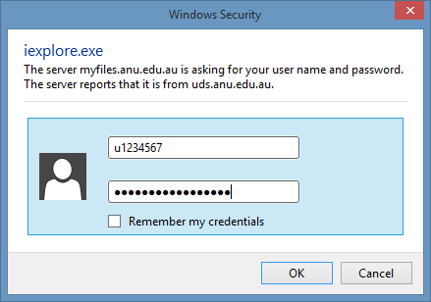

1. You are now logged in and will be able to view your documents.

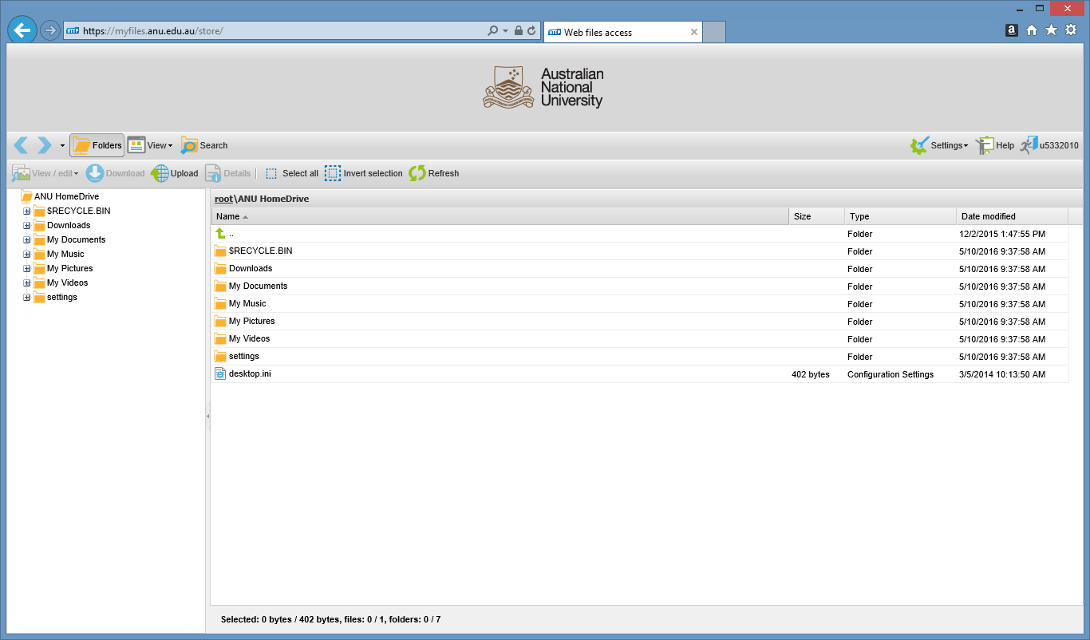

**Note:**

Secure Share folder access will automatically appear once permissions has been granted to your account and secure share folder.

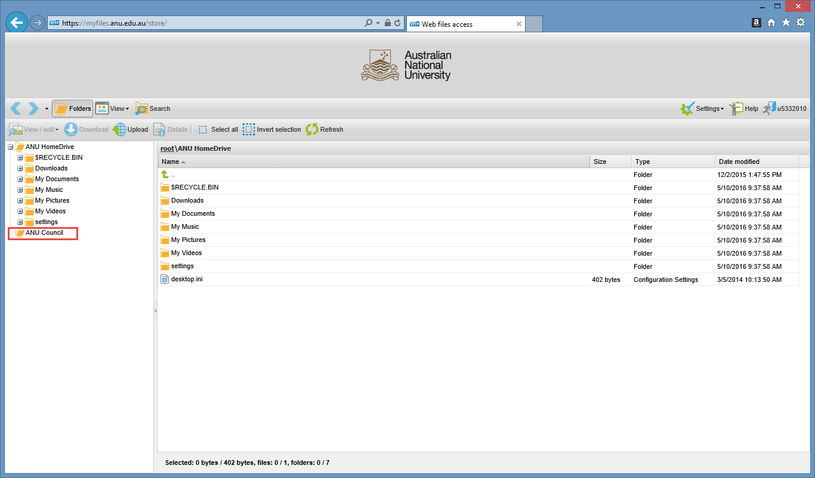

# Accessing MyFiles via iOS Devices

1. In your iOS device go to the app store, download and install the HTTP Commander app

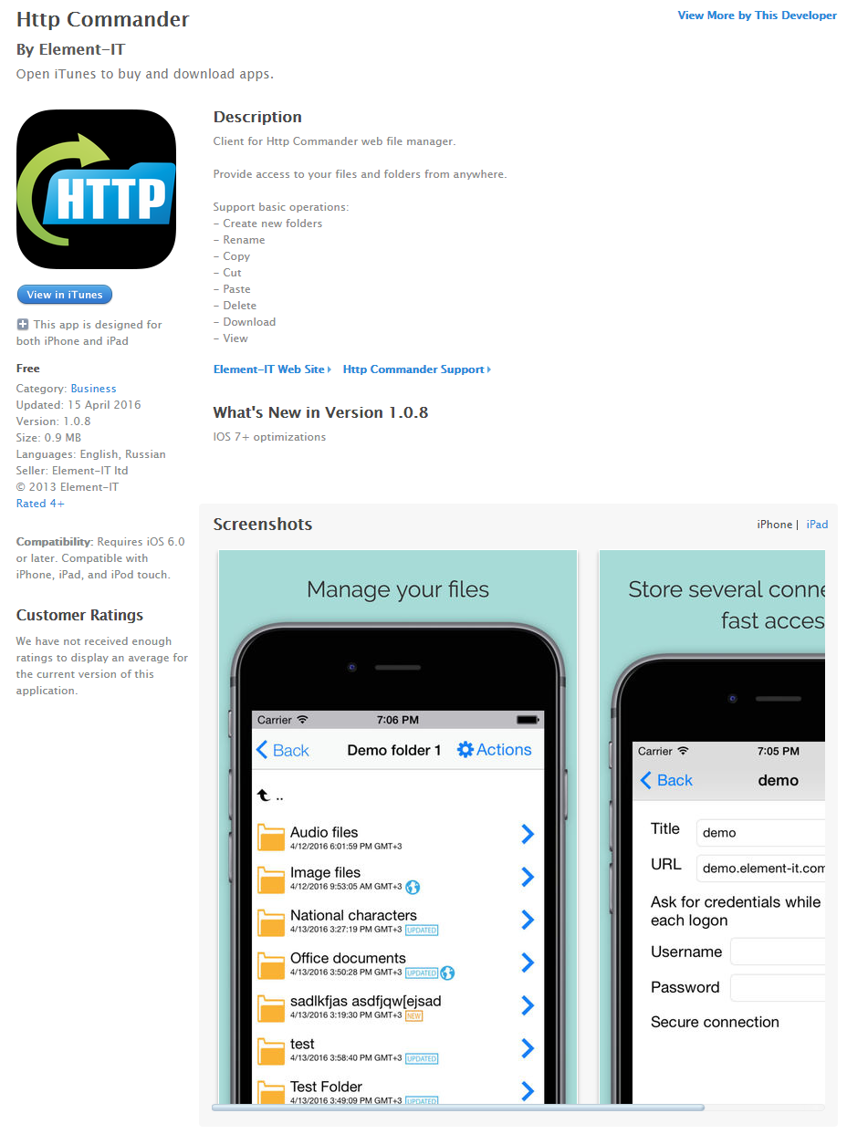

1. Launch the app

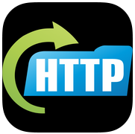

1. Click add

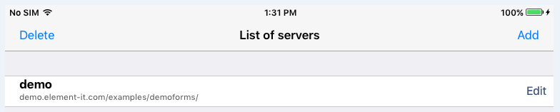

1. Enter Details

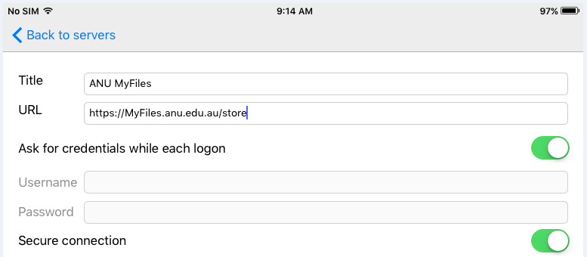

* Title: ANU Myfiles
* URL: <https://myfiles.anu.edu.au/htcomnet/>
* Turn on - ‘Ask for credentials while each logon’
* Turn on – Secure Connection

1. Click Back to servers
2. Click the New Server Connection – ANU MyFiles

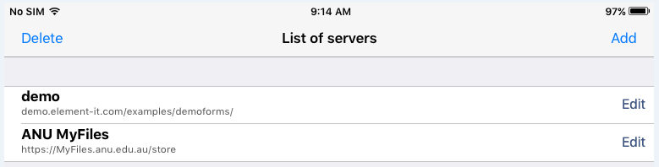

1. You will be ask to enter your login information

* User Name: <Your Uni-ID> (e.g. u1234567)
* Password: <Your ANU password>
* Click Ok

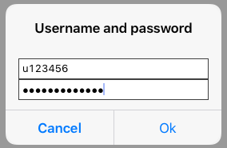

1. You are now logged in and will be able to view your documents.

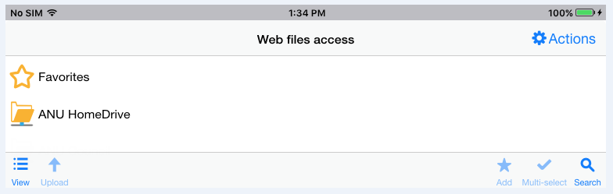

1. Continue by clicking on the ANU HomeDrive

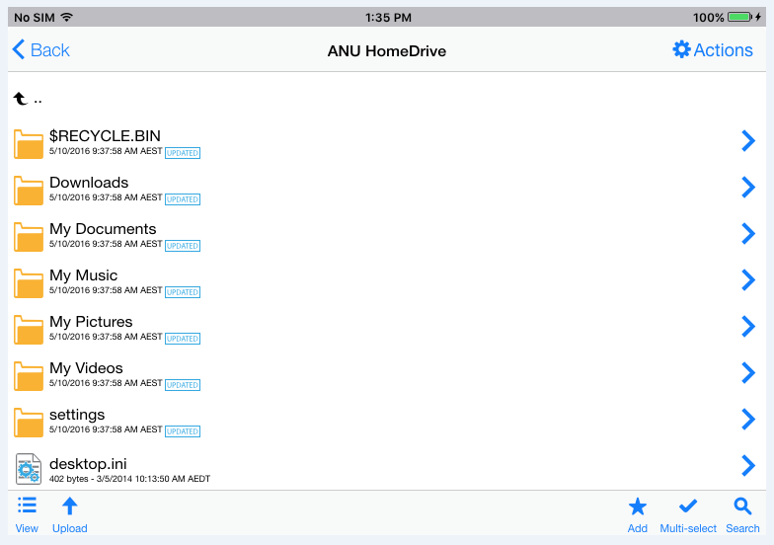

**Note:**

Secure Share folder access will automatically appear once permissions has been granted to your account and secure share folder.

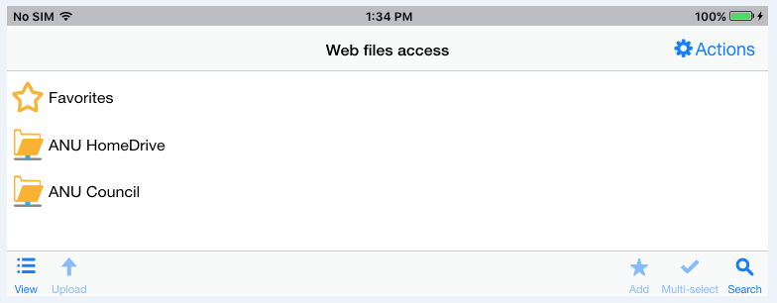

# Accessing MyFiles via Android Devices

1. In your Android device go to the Google Play store, download and install the HTTP Commander app

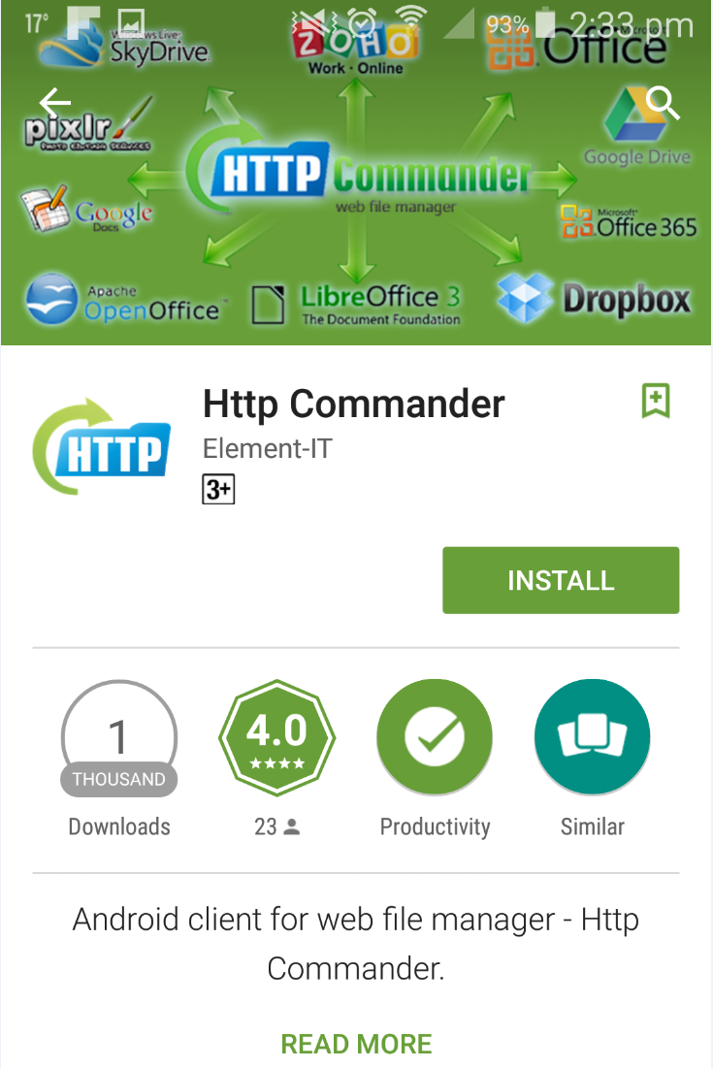

1. Click Accept

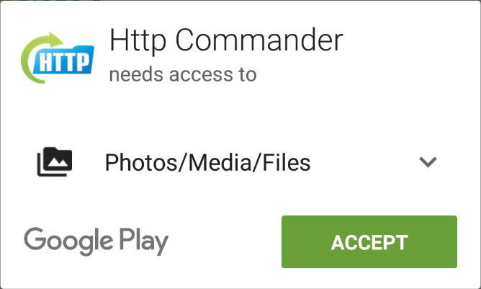

1. Launch the app

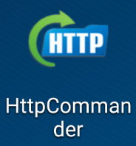

1. Click the menu button (bottom left hand button) and Click Add New

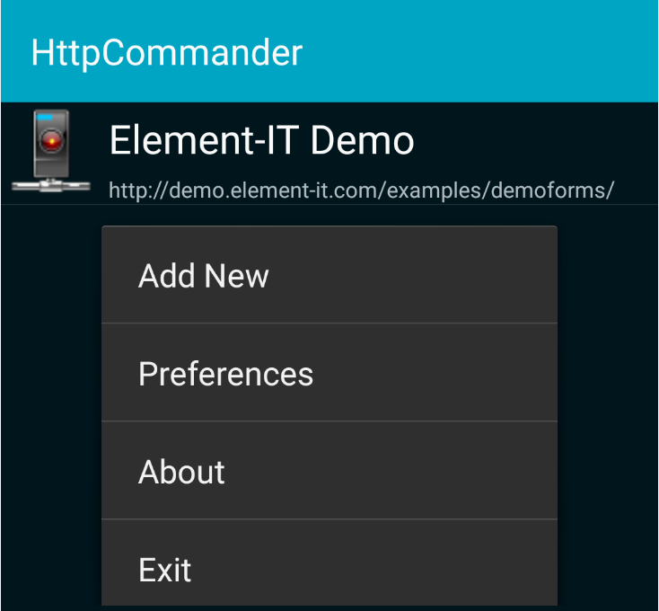

1. Enter Details

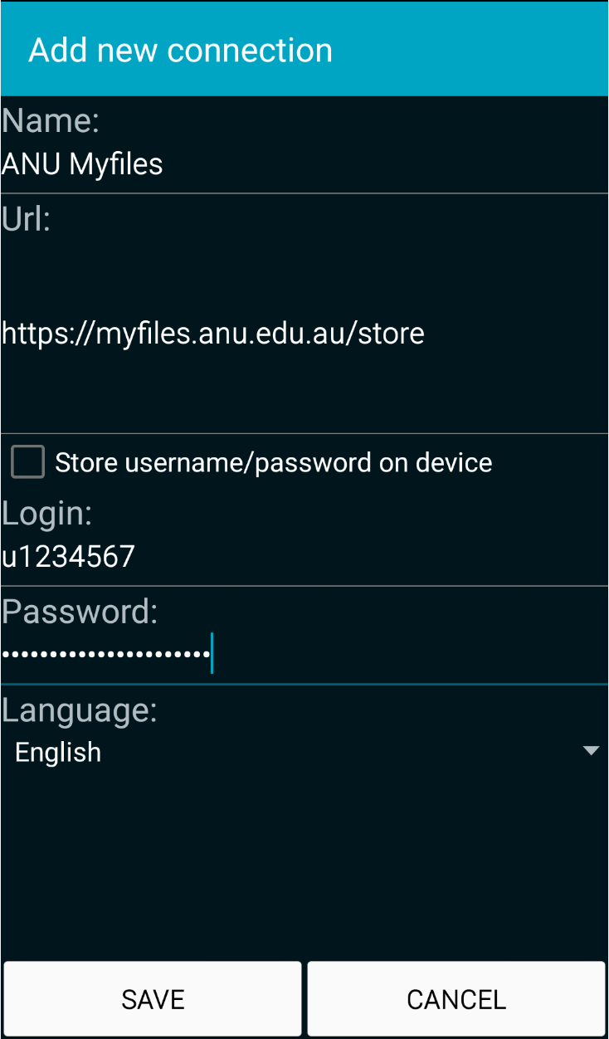

* Title: ANU Myfiles
* URL: <https://myfiles.anu.edu.au/store/>
* Uncheck - ‘Store username/password on device’
* User Name: <Your Uni-ID> (e.g. u1234567)
* Password: <Your ANU password>

1. Click SAVE
2. Click the New Server Connection – ANU MyFiles

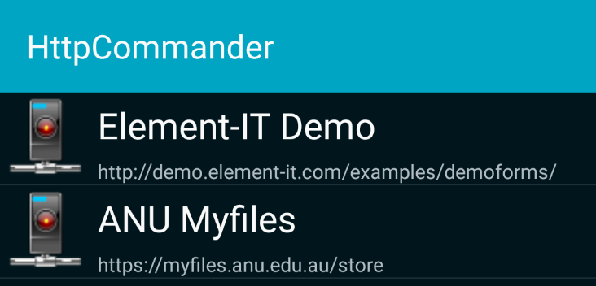

**Note:**

Re-enter your credentials if prompted

* User Name: <Your Uni-ID> (e.g. u1234567)
* Password: <Your ANU password>
* Click Ok

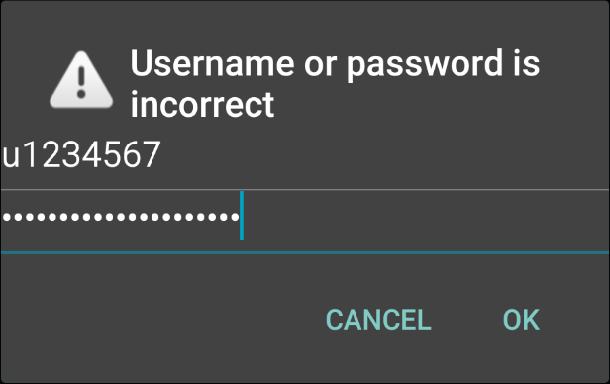

1. You are now logged in and will be able to view your documents.

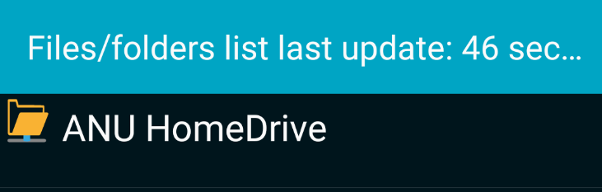

1. Continue by clicking on the ANU HomeDrive

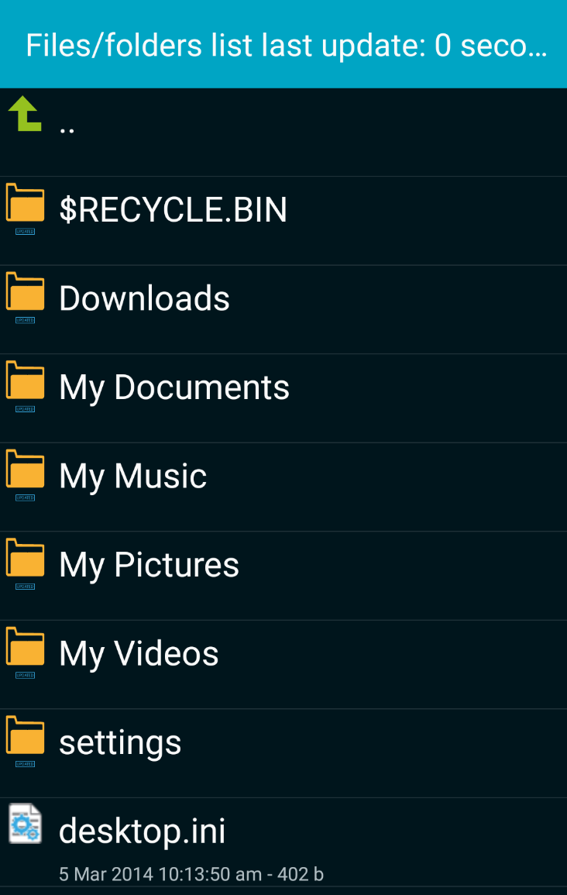

**Note:**

Secure Share folder access will automatically appear once permissions has been granted to your account and secure share folder.

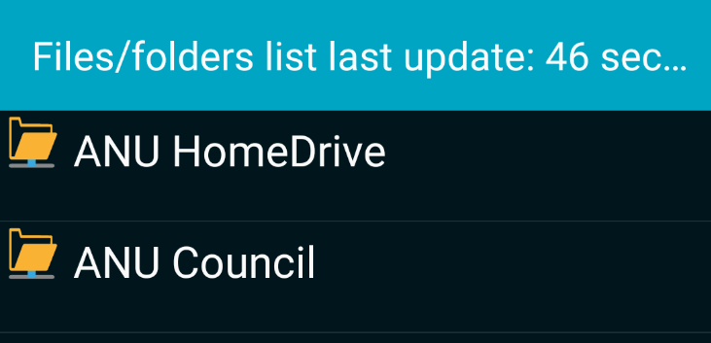

# Additional Resources

http://www.element-it.com/httpcommander-screenshots.aspx